**Assignment 3 By Group 2**

**Solution to Problem 2**

**By:**

Ivanov Stepan

Mohammad Kiarash

Pasumarthy Krishna Bharat

**Problem Description:**

Journey Details of Mr.X:

* T0 – Time when started from home.
* T1 – Time taken to walk 1 km from home to bus stop.
* T2 – Waiting time at the bus stop for arrival of bus
* T3 – Travel time in bus from source to destination bus stops.
* T4 – Time taken to walk from destination bus stop to office.

Distribution details:

* T1 – N(8,1)
* T2 – U(0,5) if there are ‘No disturbances’ , else Exp(𝜆=0.1)
* T3 – N(31,2) if there are ‘No disturbances’ else 31+Exp(𝜆=0.1)
* T4 – Need to cover 2 cases.
  + N(5,2) if X walks independently of the preceding trip.
  + N([6-((T1+T2+T3)/50)],2) if X walks with a dependency on previous trip.

**Note:** Solution is provided based on simulations performed separately for both scenarios mentioned for the calculation of **T4**

**Solution Case 1:**

Monte Carlo Simulation is performed based on the distributions to identify travel time, separately for each part of journey. Below is sample from the 100 simulations performed.

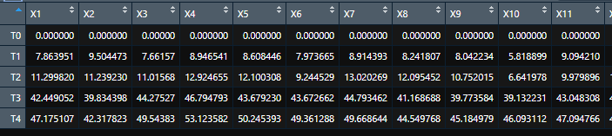

1. E[ T1 + T2 + T3 + T4 ] (Mean) = 47.0842 = 47:05 (MM:SS)
2. Travel Time Variation (Standard Deviation) = 5.979 = 05:59 (MM:SS)
3. For time variables T1-T4 we call qnorm(), qunif() and qexp() functions to calculate time periods, which cover 99% of these time distributions, considering both normal and disturbance conditions during the travel.

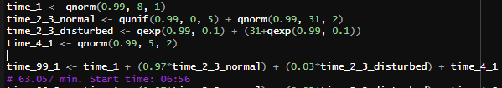

Travel Duration = 63.057 = 63:03 (MM:SS). So, Mr.X should start before 06:56(HH:MM)

Alternative intuitive approach:

When we consider total travel time for all 100 simulations, maximum time was 88.329 min and next highest is 64.796 min, which means in 99 percent of simulations total travel time is less than 65 min. So Mr.X should start from home before 06:55(HH:MM) to reach office before 08:00 with 99% probability.

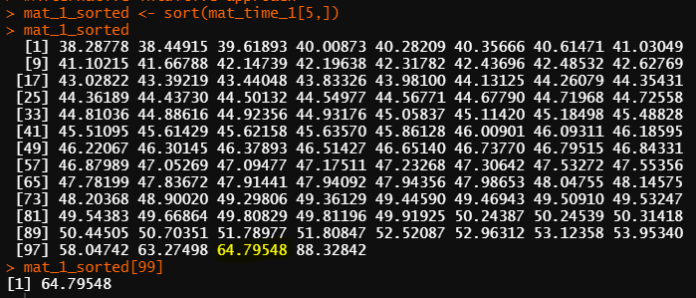

1. The distribution of the time for the trip to work is formed by combining different time distributions as below:

Norm + Unif + Exp which results in an “Exponentially modified Gaussian distribution”

With Mean and Standard Deviation values of 47:05 (MM:SS) and 05:59 (MM:SS)

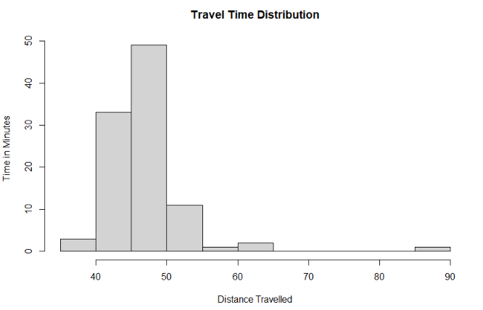

Confidence intervals based on probabilities:

* + 99% - 63:02 min
  + 95% - 58:32 min
  + 68% - 50:17 min

**Solution Case 2:**

Monte Carlo Simulation is performed based on the distributions to identify travel time, separately for each part of journey. Below is sample from the 100 simulations performed.

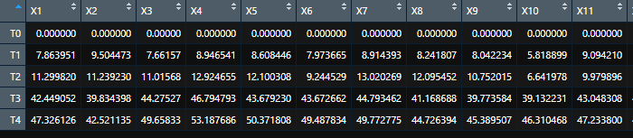

1. E[ T1 + T2 + T3 + T4 ] (Mean) = 47.24185 = 47:15 (MM:SS)
2. Travel Time Variation (Standard Deviation) = 5.979 = 05:53 (MM:SS)
3. For time variables T1-T4 we call qnorm(), qunif() and qexp() functions to calculate time periods, which cover 99% of these time distributions, considering both normal and disturbance conditions during the travel.

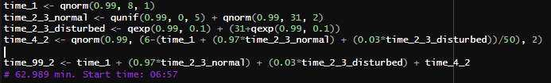

Travel Duration = 62.989 = 62:59 (MM:SS). So, Mr.X should start before 06:57(HH:MM)

Alternative intuitive approach:

When we consider total travel time for all 100 simulations, maximum time was 87.696 min and next highest is 64.635 min, which means in 99 percent of simulations total travel time is less than 65 min. So Mr.X should start from home before 06:55(HH:MM) to reach office before 08:00 with 99% probability.

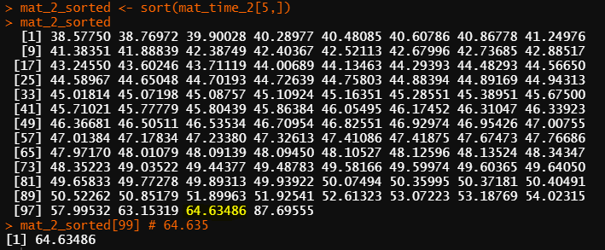

1. The distribution of the time for the trip to work is formed by combining different time distributions as below:

Norm + Unif + Exp which results in an “Exponentially modified Gaussian distribution”

With Mean and Standard Deviation values of 47:15 (MM:SS) and 05:53 (MM:SS)



Confidence intervals based on probabilities:

* + 99% - 62:59 min
  + 95% - 58:31 min
  + 68% - 50:24 min